 | Faculty of Natural and Applied Sciences  Computer Science Department
CSC 323: Object-Oriented Design
Project – Report
Submitted by:
Student ID | Name | Major
20201228 | Ray Bassel Atanas | Computer science

Project Description (around 500 words)
My project is a website that sells concert and movie tickets online.Before logging in, the user must first create an account.The first user interface in my project is the sign up page, which allows the user to create an account.The sign in page is the second user interface, which allows the user to log in if he or she already has an account.If the email or password is wrong the user won’t be able to log in. The main page of the third user interface is where the user will choose the product he wants to buy.The user has the option of purchasing movie or concert tickets.They have the option of adding items to a shopping cart or purchasing them right away.The final price will be displayed in front of the users after they have finished selecting the products and quantity desired.They can take advantage of a discount code that will save them 15% to 20%.Following that, users can choose whether they want their tickets to be physical or virtual.If the users select the virtual product, an email with a QR code will be sent to their email address, which when scanned will function as a physical ticket.Alternatively, they can purchase a physical copy of the tickets.They have the option of having their tickets delivered by mail, car, or other means. Costumers can share their opinion about various products on the comment section. We love giving the users the opportunity to communicate with eachother. The users will need to fill their address information , Country , city, postal code, address. And select the payment method they want before they finish ordering or else the order will not be placed.When Christmas time or easter time arrives the user will be given a lot of surprises like discounts on movies and concerts tickets.These 2 events will happen all along the month of December and april. My Last form is about costumers service, the users can send feedback about the website or report a bug . So the program can be bug free and user friendly as much as we can.

Class Diagram (UML)
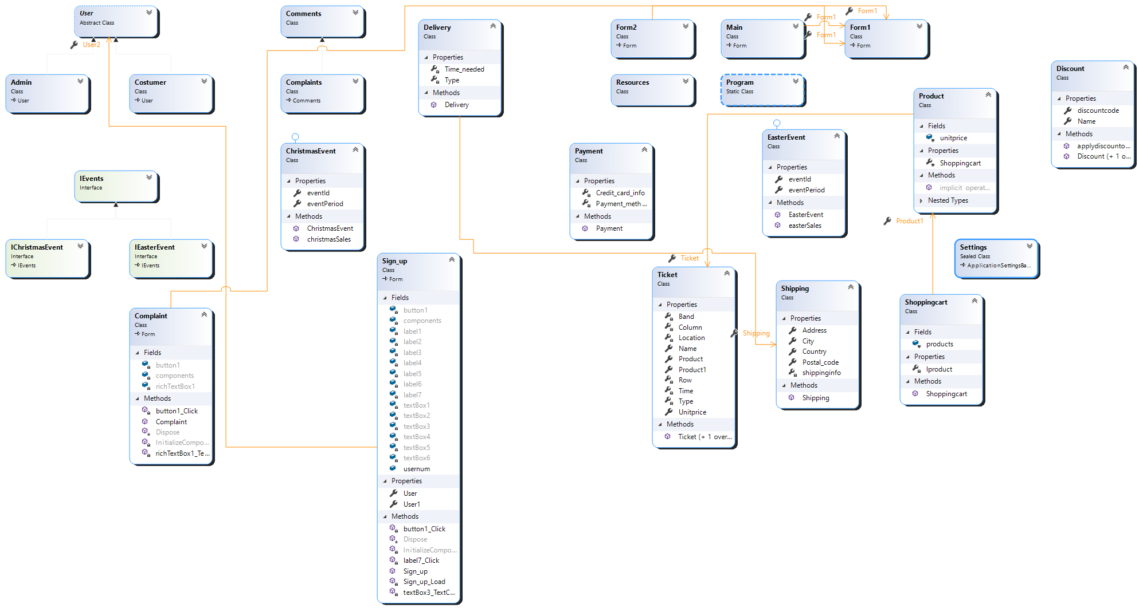

Figure 1. Class Diagram caption …
Source Code (C#)
{ public class Admin : User
{
int Salary { get; set; }
int year_of_entrance { get; set; }
int Number_of_years { get; set; }
List<User> user_list { get; set; }

public Admin(string _userid, string _email, string _password, string _firstname, string _lastname, string _address, int _salary, int _number_of_years) : base(_userid, _email, _password, _firstname, _lastname, _address)
{
Number_of_years = _number_of_years;
_number_of_years = DateTime.Now.Year - year_of_entrance;
void salary_augmentation()
{

if (Number_of_years < 2)
{
Salary = 1500;
}
else if (Number_of_years >= 2)
{
Salary = 2000;
}

}
}

void remove_user(User Id)
{
user_list.Remove(Id);

}
public override string printinfo()
{
return base.printinfo();
this.Firstname = "Admin";
this.Password = "12345678";
}
}
}
Figure 2. class Admin.
public class ChristmasEvent: IChristmasEvent
{
public int eventId { get; set; }
public string eventPeriod { get; set; }
public void christmasSales()
{
MessageBox.Show($"It's {eventPeriod}, so Christmas is here, you will get 25% discounts on all tickets!");
foreach (var ticket in Form1.allTickets)
{
ticket.Unitprice = ticket.Unitprice - (ticket.Unitprice * 0.25);
}
}
public ChristmasEvent(int _eventid,string _eventperiod)
{
eventId = _eventid;
eventPeriod = _eventperiod;
}
}
Figure 3. class ChristmasEvent.
public class Comments
{

string comment { get; set; }
DateTime comment_time { get; set; }
List<Comments> lcomment;
public Comments(string _comments,DateTime _comment_time)
{
comment = _comments;
comment_time = _comment_time;
}

}
Figure4. Comments
public class Complaints: Comments
{
string Feedback { get; set; }
string Errortype { get; set; }
Complaints(string _comment, DateTime _comment_time, string _feedback, string _errortype) : base(_comment, _comment_time)
{
Feedback = _feedback;
Errortype = _errortype;

}
}
Figure5. Complaints.
public class Costumer:User
{
string credit_cart_info;
string credit_card_pin;
List<Costumer> Shopping_cart;
public Costumer(string userid, string email, string password, string firstname, string lastname, string address,string credit_info,string credit_pin) : base(userid, email, password, firstname, lastname, address)
{
credit_cart_info = credit_info;
credit_card_pin = credit_pin;

}
public Costumer(string userid, string email, string password, string firstname, string lastname, string address) : base(userid, email, password, firstname, lastname, address)
{

}
}
Figure6. Costumer.
class Delivery
{
bool Type { get; set; }
DateTime Time_needed { get; set; }

internal enums.Delivery_type Delivery_type
{
get => default;
set
{
}
}

public Delivery(bool _type,DateTime _timeneeded){
Type = _type;
Time_needed = _timeneeded;

}
}
enum Delivery_type
{
By_car,
By_boat,
By_Mail,
By_plane

}
Figure7. Delivery.
class Discount
{
public virtual string Name { get; set; }
public virtual string discountcode { get; set; }

public virtual Shoppingcart applydiscountoncart(Shoppingcart b)
{
return b;//to be overriden
}

public Discount(string _code) {
discountcode = _code;
}
public Discount(string _Name, string _code)
{
Name = _Name;
discountcode = _code;
}
}
Figure8. Discount.
class EasterEvent: IEasterEvent
{
public int eventId { get; set; }
public string eventPeriod { get; set; }
public void easterSales()
{
MessageBox.Show($"It's {eventPeriod}, so Easter is here, you will get 50% discounts on all tickets!");
foreach (var ticket in Form1.allTickets)
{
ticket.Unitprice = ticket.Unitprice - (ticket.Unitprice * 0.5);
}
}
public EasterEvent(int _eventid, string _eventperiod)
{
eventId = _eventid;
eventPeriod = _eventperiod;
}
}
Figure9. EasterEvent.
class GetNumber
{
private static GetNumber instance;
private GetNumber() { }
public static GetNumber get_instance()
{
if(instance== null)
{
instance = new GetNumber();

}
return instance;

}
private static int Id;
public List<int> ids = new List<int> { };
public int get_number()
{
Random rand = new Random();
int num = rand.Next(0, 100);
bool found = true;
foreach (var id in ids)
if (num == id) {
found = false;

}
if (found == true)
return Id;
else
return get_number();
}
}
Figure10. GetNumber.
interface IChristmasEvent: IEvents
{
void christmasSales();
}
Figure11. IChristmasEvent
interface IEasterEvent: IEvents
{
void easterSales();
}
Figure12. IEasterEvent
interface IEvents
{
int eventId { get; set; }
string eventPeriod { get; set; }
}
Figure13. IEvent
public class Payment
{
string Payment_method { get; set; }
string Credit_card_info { get; set; }

public Payment(string _paymentmethod, string _creditcard)
{
Payment_method = _paymentmethod;
Credit_card_info = _creditcard;
}
}

Figure14. Payment
public class product
{
public string Productid { get; set; }
public string Productname { get; set; }
public string Description { get; set; }
public double Unitprice { get; set; }
public int Productquantity { get; set; } = 1;

public List<product> lproducts;

public product( string _productname, double _unitprice)
{
Productname = _productname;
Unitprice = _unitprice;
}
public product(string _productname, int _productquantity,double _unitprice)
{
Productquantity = _productquantity;
Productname = _productname;
Unitprice = _unitprice;
}
public product( string _productname, int _unitprice, string _description)
{

Productname = _productname;
Unitprice = _unitprice;
Description = _description;

}
public void editproductinfo( string _name, int _price, string _description)
{

Productname = _name;
Unitprice = _price;
Description = _description;

}

public virtual string printinf()
{
StringBuilder a = new StringBuilder();

a.Append($" productname={Productname } unitprice={Unitprice} quantity={Productquantity}");
a.AppendLine();
a.Append($"description={Description}")
.AppendLine();
return a.ToString();

}

public static implicit operator product(Product v)
{
throw new NotImplementedException();
}
}

}
Figure15. Product
public class Shipping
{
public string Address { get; set; }
public string Postal_code { get; set; }
public string City { get; set; }
public string Country { get; set; }
List<Shipping> shippinginfo { get; set; }
public Shipping(string _country, string _city, string _postal_code, string _address)
{
Country = _country;
City = _city;
Postal_code = _postal_code;
Address = _address;

}

}
Figure16. Shipping
public class Shoppingcart
{
internal object products;

List<Product> lproduct { get; set; }

public Product Product1
{
get => default;
set
{
}
}

public Shoppingcart(List<Product>_products) {
lproduct = _products;
}
}
Figure17. ShoppingCart
public class Ticket
{

string Type { set; get; }
char Row { set; get; }
int Column { set; get; }
public string Name { get; set; }
DateTime Time { set; get; }
string Location { set; get; }
string Band { set; get; }
public double Unitprice { get; set; }

public Product Product
{
get => default;
set
{
}
}

public Product Product1
{
get => default;
set
{
}
}

public Ticket(string _type, char _row, int _column, string _name, DateTime _time, string _location )
{

Type = _type;
Row = _row;
Column = _column;
Name = _name;
Time = _time;
Location = _location;

}
public Ticket(string _type, string _name, double _price)
{
Type = _type;

Name = _name;
Unitprice = _price;
}
}
Figure17. Ticket

public abstract class User
{
public string Id { get; set; }
public string Email { get; set; }
public string Password { get; set; }
public string Firstname { get; set; }
public string Lastname { get; set; }
public string Address { get; set; }

public User(string _userid, string _email, string _password, string _firstname, string _lastname, string _address)
{
Id = _userid;
Password = _password;
Email = _email;
Firstname = _firstname;
Lastname = _lastname;
Address = _address;
}
public virtual string printinfo() {
StringBuilder a = new StringBuilder();

a.Append($" ID={Id } Email={Email} First Name={Firstname} Last Name {Lastname} Address {Address}");
a.AppendLine();
return a.ToString();

}
}
Figure18. User
public partial class Main : Form
{

string stdDetails = "{0,-20}{1,-30}{2,-50}";
int selectedItemIndex = -1;
string StdDetails2 = "{0,-20}{1,-50}";
public Main()
{
InitializeComponent();

}

private void comboBox1_SelectedIndexChanged(object sender, EventArgs e)
{

}

void Main_Load(object sender, EventArgs e)
{

info.Items.Add(string.Format(stdDetails, "Product Name", "Price per unit", "Quantity"));

}

private void listBox1_SelectedIndexChanged(object sender, EventArgs e)
{

}

private void checkBox1_CheckedChanged(object sender, EventArgs e)
{
var dategnr = new DateTime(2021, 11, 13, 6, 10, 0);
Ticket GNR = new Ticket("Concert", 'A', 10, "Guns and Roses", dategnr, "Beirut");
Ticket Eagles = new Ticket("Concert", 'A', 15, "Eagles", dategnr, "Beirut");
Ticket Scorpions = new Ticket("Concert", 'B', 20, "Scorpions", dategnr, "Beirut");
Ticket BB = new Ticket("Concert", 'C', 10, "Bra", dategnr, "beirut");
if (checkBox1.Checked)
fillList1();
else
{
listticket.Items.Clear();
fillList2();
}
}

private void fillList1()
{
if (checkBox1.Checked)
{
listticket.Items.Add("Guns and Roses");
listticket.Items.Add("Eagles");
listticket.Items.Add("Scorpions");
listticket.Items.Add("Breaking Benjamin");
listticket.Items.Add("George Michael");
}
}
private void fillList2()
{
if (checkBox2.Checked)
{
listticket.Items.Add("The Godfather");
listticket.Items.Add("Fast and Furious");
listticket.Items.Add("Iron Man");
listticket.Items.Add("The Dictator");
listticket.Items.Add("The Founder");
}
}
private void checkBox2_CheckedChanged(object sender, EventArgs e)
{

if (checkBox2.Checked)
fillList2();
else
{
listticket.Items.Clear();
fillList1();
}
}

private void Information_SelectedIndexChanged(object sender, EventArgs e)
{

}

private void groupBox1_Enter(object sender, EventArgs e)
{

}

private void listBox1_SelectedIndexChanged_1(object sender, EventArgs e)
{

}

private void textBox1_TextChanged(object sender, EventArgs e)
{
string Qte = textBox1.Text;
}

static double Final_price = 0;

public void button1_Click(object sender, EventArgs e)
{
int Quantity = int.Parse(textBox1.Text);
string ticketName = listticket.Items[listticket.SelectedIndex].ToString();

foreach (var ticket in Form1.allTickets)
{
if (ticket.Name == ticketName)
{
info.Items.Add(string.Format(stdDetails, ticketName, ticket.Unitprice, Quantity));

Final_price += ticket.Unitprice * Quantity;
Fprice.Text = Final_price.ToString();
}

}

}
Figure19. Main form
public partial class Form2 : Form
{
public Form2()
{
InitializeComponent();
}

public Form1 Form1
{
get => default;
set
{
}
}

private void textBox3_TextChanged(object sender, EventArgs e)
{

}

private void textBox4_TextChanged(object sender, EventArgs e)
{

}

private void button1_Click(object sender, EventArgs e)
{
string email = textBox3.Text;
string password = textBox4.Text;
foreach(var user in Sign_up.usernum)
{
if(email == user.Email)
{
if (password == user.Password)
{
MessageBox.Show("welcome", "sign in successful", MessageBoxButtons.OK);
}
else
{
MessageBox.Show("Password not valid!");
}
}
else
{
MessageBox.Show("Email not valid!");
}
}
}
}

Figure20. Log in form
public partial class Sign_up : Form
{
public Sign_up()
{
InitializeComponent();

}

private void Sign_up_Load(object sender, EventArgs e)
{

}
public static List<Costumer> usernum = new List<Costumer>()
{
new Costumer("1234","Ray","rayA","Ray","Atanas","Lebanon")

};

private void button1_Click(object sender, EventArgs e)
{

string First_name = textBox1.Text;
string last_name = textBox2.Text;
string Email = textBox3.Text;
string Password = textBox4.Text;
string CPassword = textBox5.Text;
string Address = textBox6.Text;
Random num = new Random();
string Id = "20201" + num.ToString();
if (Password != CPassword)
{
_ = MessageBox.Show("Password and confirmation don't match");
}

else
{
MessageBox.Show("Welcome to our family!");
}
Costumer nuser = new Costumer(Id,textBox1.Text, textBox2.Text, textBox3.Text,textBox4.Text,textBox6.Text);
usernum.Add(nuser);

}

private void textBox3_TextChanged(object sender, EventArgs e)
{

}

private void label7_Click(object sender, EventArgs e)
{

}

}
Figure21. sign up form
public partial class Form1 : Form
{
public Form1()
{
InitializeComponent();
}

public static List<Ticket> allTickets = new List<Ticket>
{
new Ticket("Concert","Guns and Roses",7),
new Ticket("Concert","Eagles",6),
new Ticket("Concert","Scorpions",9),
new Ticket("Concert","Breaking Benjamin",11),
new Ticket("Concert","George Michael",10),
new Ticket("Movie","The Godfather",7),
new Ticket("Movie","Fast and Furious",6),
new Ticket("Movie","Iron Man",9),
new Ticket("Movie","The Dictator",11),
new Ticket("Movie","The Founder",10),
};

private void button1_Click(object sender, EventArgs e)
{
Form2 Login = new Form2();
Login.ShowDialog();
}

private void button2_Click(object sender, EventArgs e)
{
Sign_up signup = new Sign_up();
signup.ShowDialog();
}

private void button3_Click(object sender, EventArgs e)
{
DateTime eventdate = DateTime.Now;
int month = eventdate.Month;
if(month == 12)
{
ChristmasEvent a = new ChristmasEvent(1, "Christmas");
a.christmasSales();
}
if(month == 4)
{
EasterEvent a = new EasterEvent(2, "Easter");
a.easterSales();
}
Main main = new Main();
main.ShowDialog();
}

private void Form1_Load(object sender, EventArgs e)
{

}

private void button4_Click(object sender, EventArgs e)
{
Complaint complaint = new Complaint();
complaint.ShowDialog();
}
}
Figure22. form 1

Include as many figures as you need to show the different parts of your source code.

Descriptions of how and where you have used key concepts
Concept | Description (around 30 words each)  refer to the class diagram and source code figures as you see fit
Abstraction (abstract classes and/or interfaces) | Abstarct classes were used when I didn’t need to instantiate the classes themselves but I only needed the classes that inherit from them example Users I didn’t instantiate User but I used Admin and Costumer.
Concrete classes | Concrete classes were used when I needed to instantiate the classes example Ticket or Product I instantiate these classes using the new keyword .
Namespaces | In this project we have the “CSC323_project Project” namespace and I created 10 other namespace including “CSC323_project.Users”,  “CSC323_project.Tickets”etc.. each of these namespaces contains different classes
Methods | Most of the classes have more than one methods for example eastersale() or printinfo for the class User(it’s also overiden in Admin and costumer).
Properties | All the classes have one or more properties example User has string FirstName,another propertie in Tickets string Type.
Overriding of methods and/or properties | Overiding is used by classes that inherit from an abstract class example User is an abstract class it has the method printinfo() that will print the user info when called, Admin is a concrete class that inherit from user When printinfo() is called for Admin it will print other information specific to the Admin. I used the overriding keyword.
Constructor overloading | Constructor overloading was used in multiple classes example in costumer I overloaded the Constructor with other parameters so it could be used in other purposes. One constructor takes (_productname, _unitprice) the other takes  _(productname,productquantity,unitprice)
Enumeration (Enum) | The enums were used to enumerate the types of transports in delivery class it can be a car,plane, boat and finally by mail. I used the enum keyword.
Collections (e.g., Lists) | List were created to store multiple variables example when the user signs up with a new account the credentials entered will be stored in a List costumer to be used later in the project
Loops (e.g., foreach) | Loops were created example (foreach) to go through lists to find elements needed or even to check if these elements were present in the lists.For example in the list alltickets the foreach was used to display the Tickets information in a listbox.

SOLID Principle | Description of where the principle is realized and for what purpose (around 50 Words)
1) Single Responsibility | The single responsibility principle was realized by giving each class the methods that does specific things that are related to the class. For example Discount was not represented as a method of product because it woul violate the single responsibility principle.
2) Open-Closed | The open-closed principle was realized by giving each main component of the shopping system an interface and/or an abstract class that contains the general properties and elements that each component needs and that these classes are extended with the desire wanted. F example the user class contains properties that the classes admin and costumer extend through inheritance.
3) Liskov Substitution | Liskov substitution was realized by making sure that the parent class do not contain properties or methods that will create confusion to the classes that inherit from them. For example in User we don’t have any properties that are causing confusion in Admin and Costumer.
4) Interface Segregation | Interface segregations principle was applied when a class contains multiple methods and different clients want each a different method from that class so interface segregation was applied by creating class that has a relationship with the client needs. For example I created an interface event that has 2 interfaces inherit from it. These 2 interfaces will make discounts on all tickets in around Christmas and easter time.
5) Dependency Inversion | Dependency inversion principle was applied also by the use of polymorphism, in other words, creating an abstract class and extend it with children classes that overrides the behavior of the abstract class methods. For example I overrode the user class so the function printinfo() that will print the user information will print other information for th admin and for the costumer even tho they inherit from the class User.

GOF Design Pattern | Description of where the pattern is realized and for what purpose (around 50 Words)
1)Prototype | Prototype design pattern was used in the product base namespace, the abstract product class has a clone function that the physical product and ticket class override and the client that calls the clone function is shopping cart class that calls it when adding a product to an order or cart. The reason I chose it is because in case I applied a discount, the unit prices of the cloned products will change and not the unit price of the product.
2)Strategy | The strategy design pattern is applied in the Comment feature, we have a class that contains the basic properties of a comment class and apply methods and inherits from it is the different behaviors of a discount. The reason I chose it because we have different types of comments(Comments and complaints) and each one of them behaves in a different way.
3) singleton | Singleton was used when I only need exactly one Instance of a certain class throughout the application lifetime, and all the classes that have a relationship with that class takes the single object as an instance. I created a class that assigns an Id to the users and products in my project.

User Interface (Windows Forms)
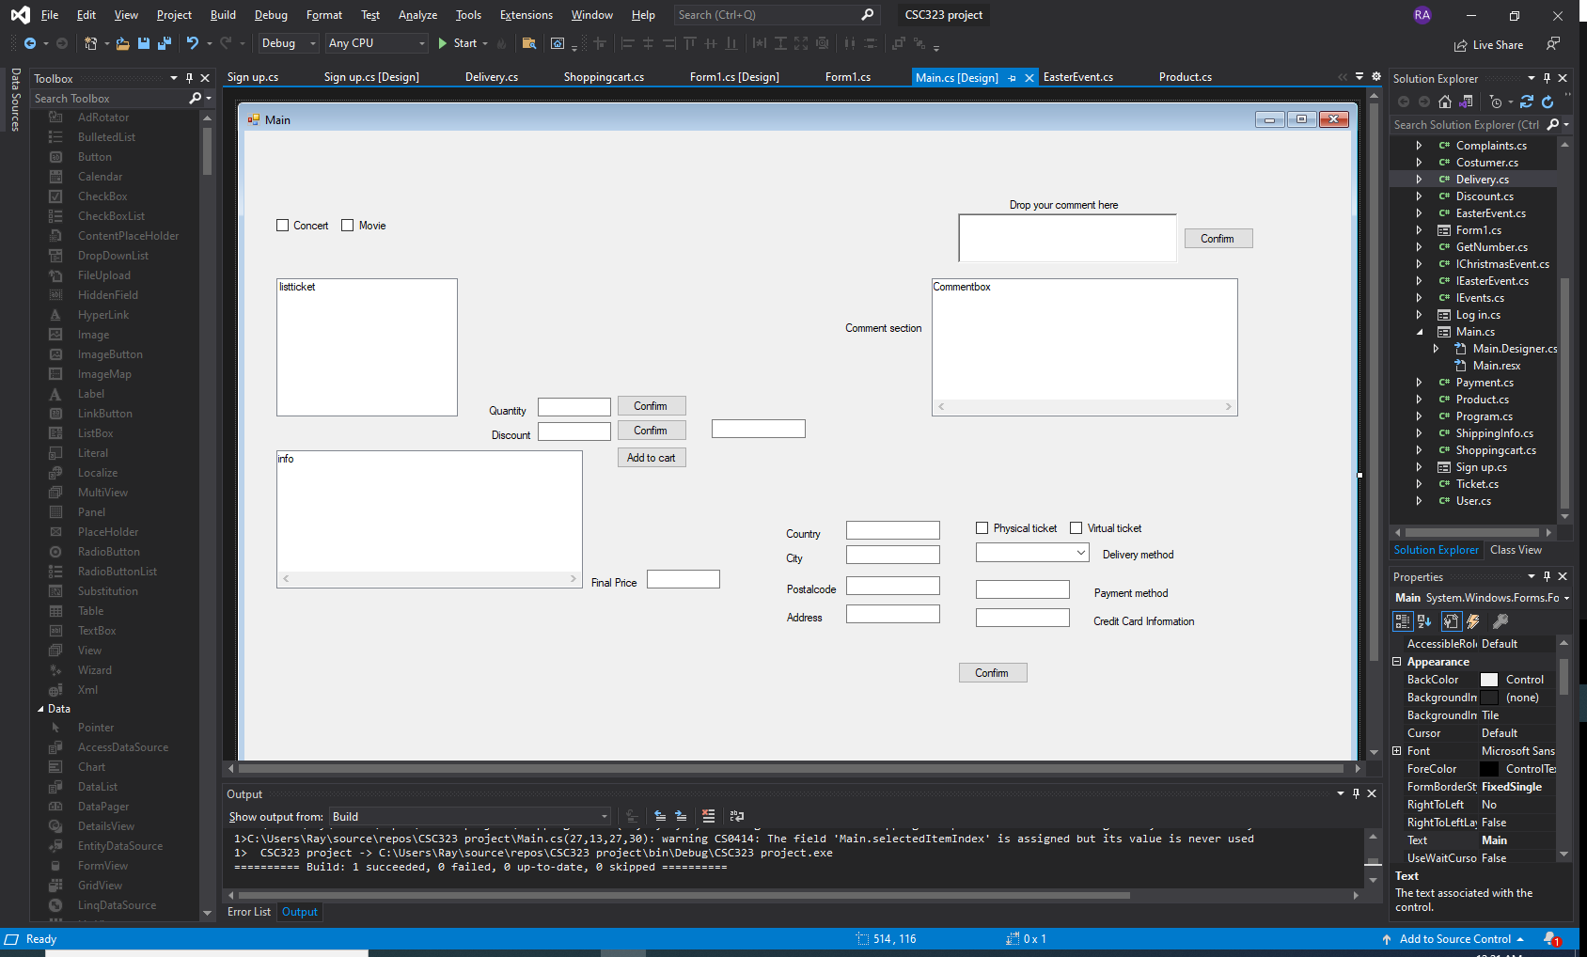
Figure n. User Interface caption
Brief Description of UI (around 50 words)
In this User interface we first have 2 boxes that will let the user specify the type of ticket he/she wants to buy concert or movie. The list box under the 2 boxes will display the tickets available and will let the user select the tickets they want. Quantity will let the user select the quantity desired. Discount will apply a discount on the final price if the discount code is valid. Info box will list all the tickets selected by the user with the quantity and the price of each ticket. Final price will display the final price of all the tickets selected. The comment section will let users interact with eachothers the box under drop your comment here will display all the comments, And finally the box under the comment section will let the user specify his/her address in details and will let them select if they want a virtual or a physical product, and the type of delivery they want.

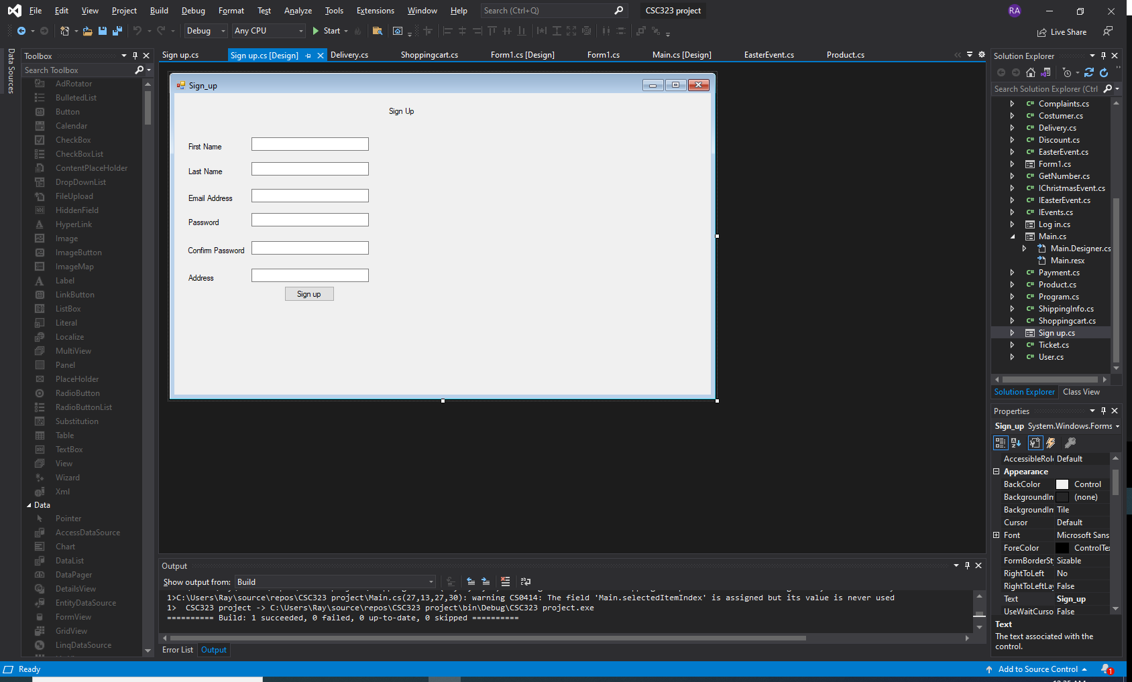
The Sign Up User interface will let the users create an account so they can sign in later. The users will have to fill their information in the textboxes after that their credentials will automatically be saved in a list to be used later in the program.

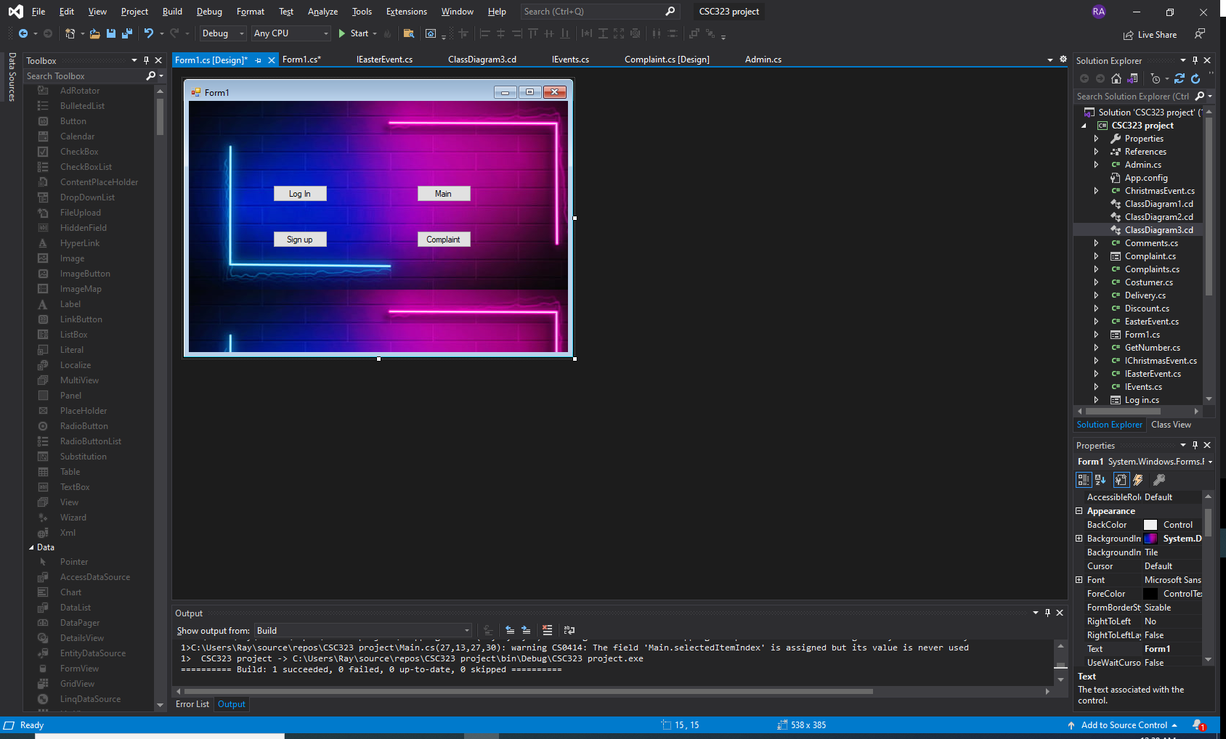
The Home page interface is where the users will enter the sign up page, login main page or the complait page it the core of the project where all the user interfaces join each others .It’s clear enough so the user won’t be confused.
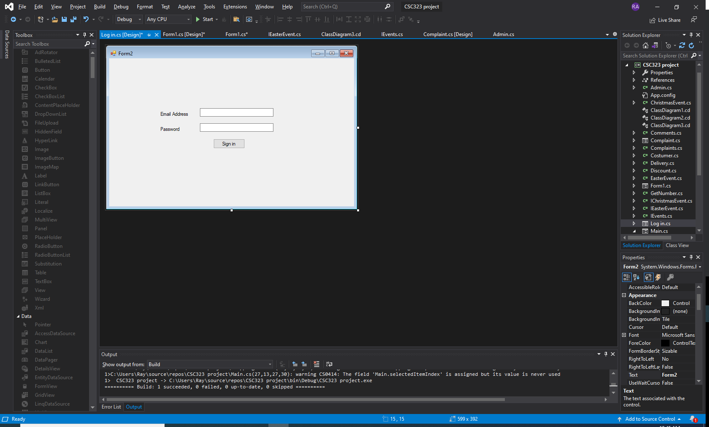
The login interface is where the users will be able to sign in. If the email or password is wrong or invalid the user won’t be able to login otherwise if all the credentials are right the user will be able to sign in.
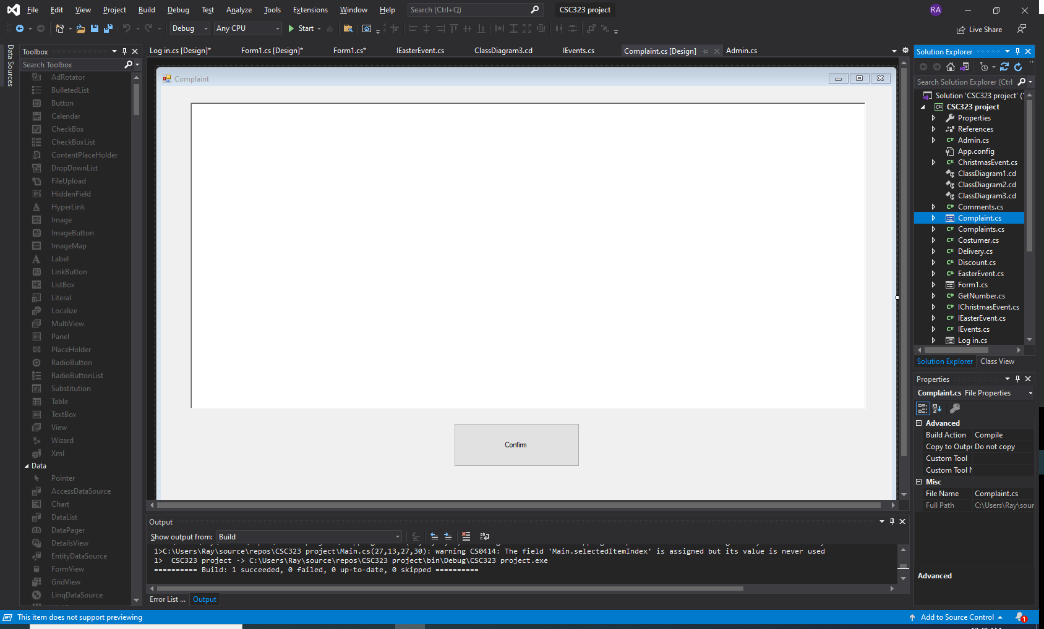
The complaint user interface will let the users ask for help if they encounter any problem or even if they are having issues due to a bug they can send a complaint to so the project can run smoothly.

